Modify the Services app: Use a Progress Bar view instead/in addition to the Toast to display the progress made by the service.

MainActivity.java : This class extends 'AppCompatActivity' in the Android app's 'MainActivity.java' and manages the UI and service interactions. It creates a 'ProgressBar' to display download progress and handles 'MyService' start/stop via buttons. When a file download is complete, the activity registers a 'BroadcastReceiver' to update the progress bar and display a toast. A manually defined flag for broadcast receiver registration ensures compatibility with API levels 31 and above.

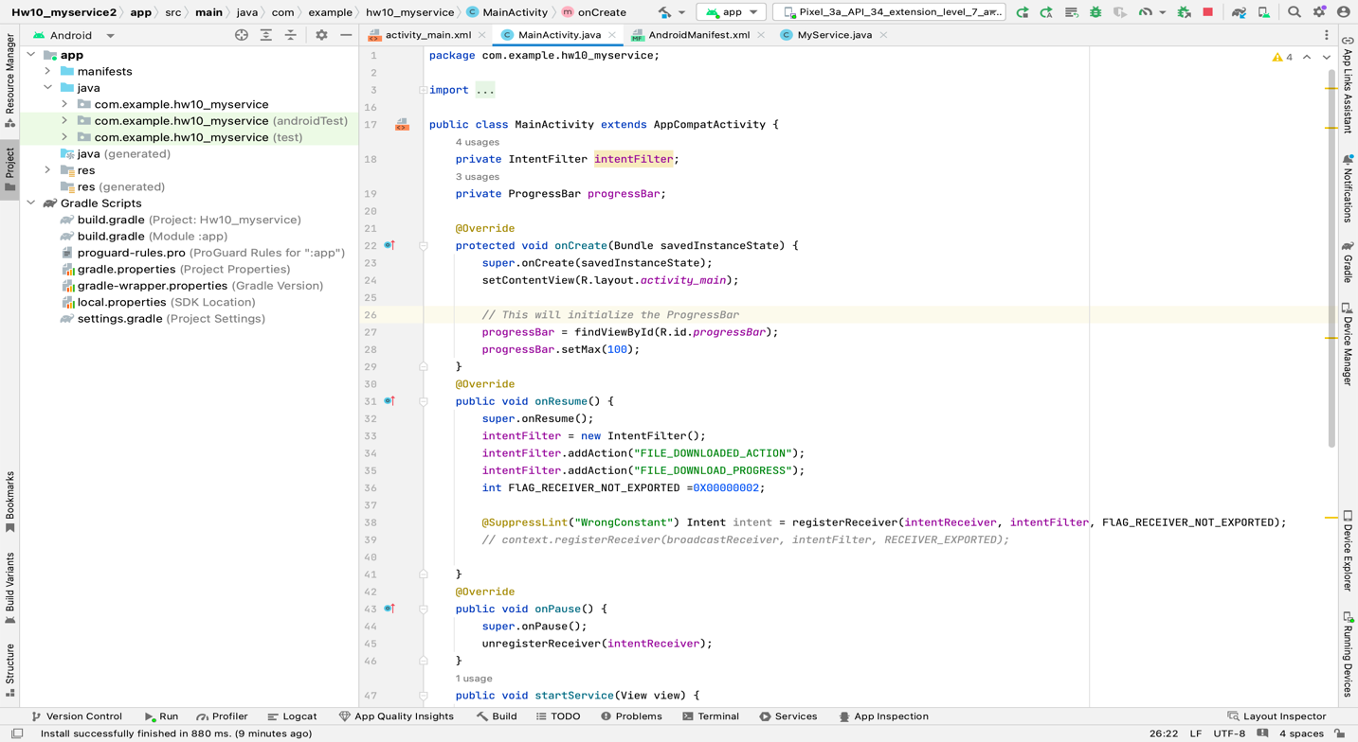

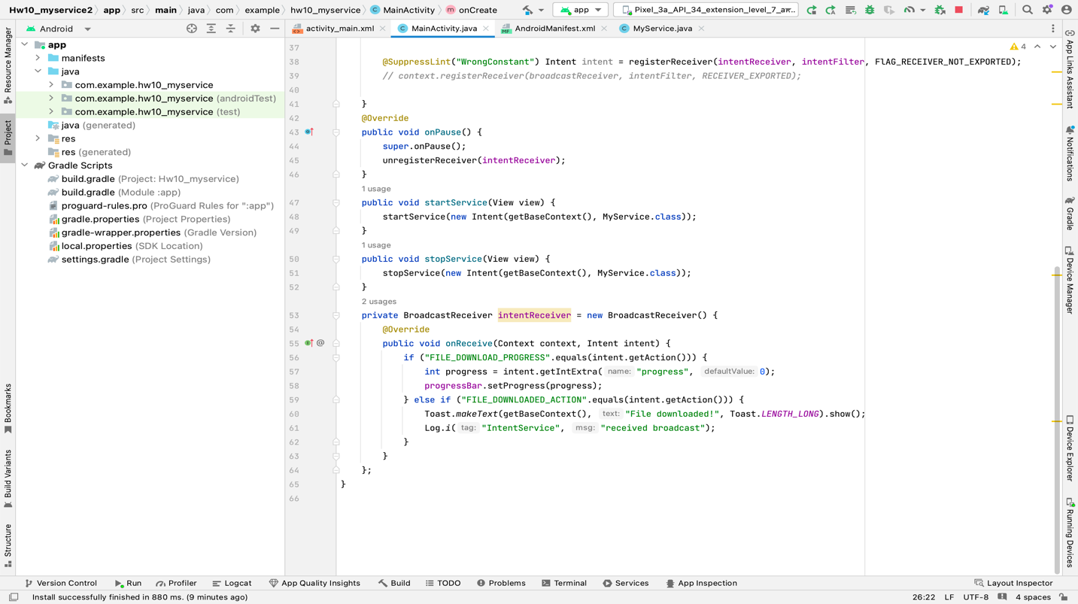
Activity_main.xml : 'ConstraintLayout' is used in this XML layout to establish the user interface for 'MainActivity' in an Android app. It has two buttons for initiating and stopping a service, each with certain dimensions and location requirements. In addition, a horizontal 'ProgressBar' is centrally aligned and positioned below the start service button to graphically display the progress of a task.

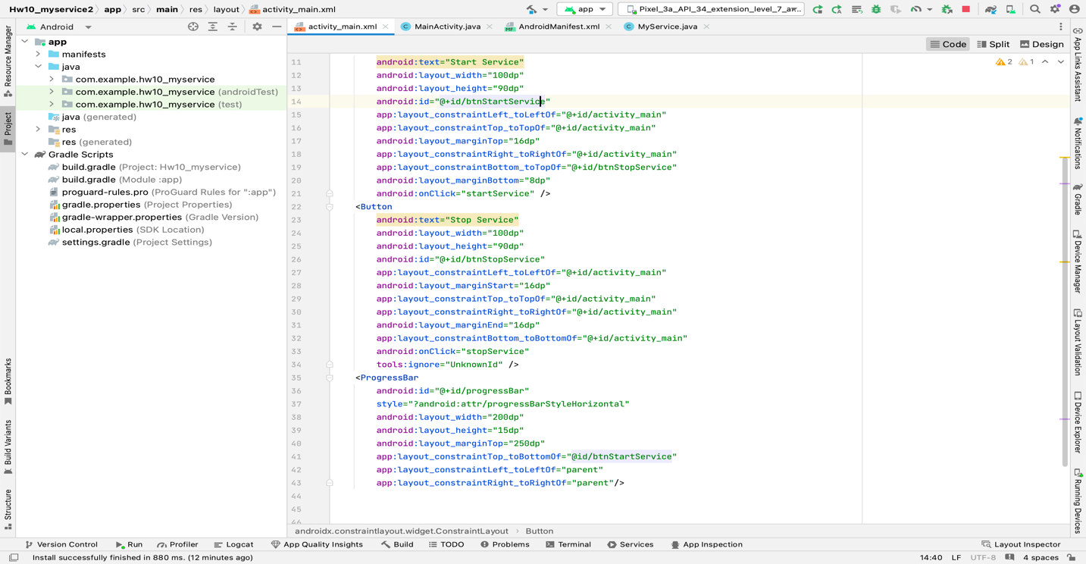

Myservice.java : In the Android app, 'MyService' is a 'IntentService' that handles background tasks. It simulates downloading a file by looping through it and pauses at intervals, during which it broadcasts progress updates using the 'FILE_DOWNLOAD_PROGRESS' action. When the simulated download is complete, it sends a broadcast with the 'FILE_DOWNLOADED_ACTION' action. The main methods are 'onHandleIntent,' which orchestrates the download process and broadcasts completion, and 'DownloadFile,' which mimics the file download and broadcasts the progress on a regular basis.

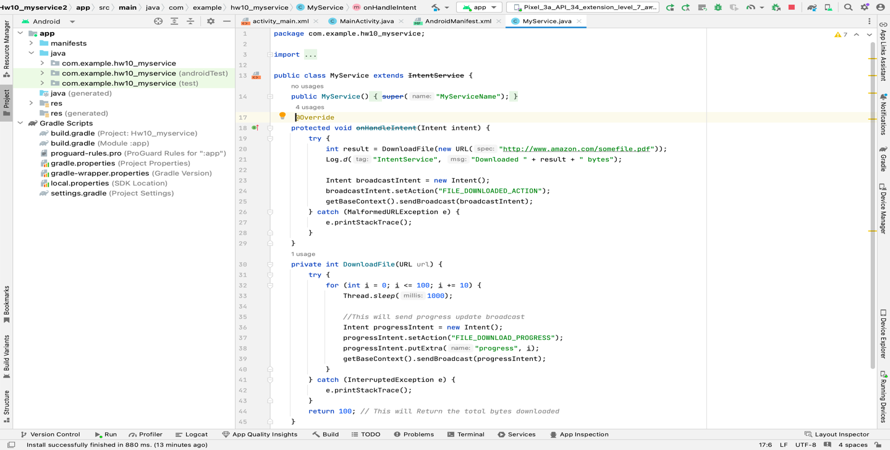
Below are the screenshots of the app running in the emulator :

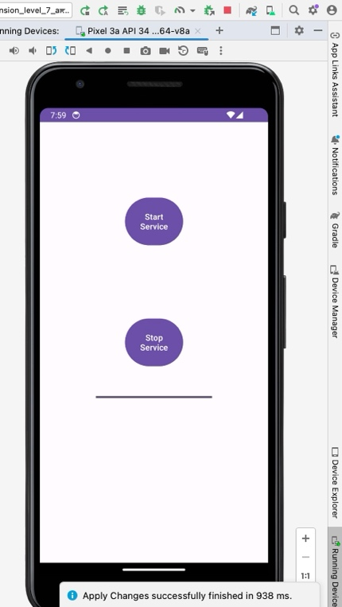
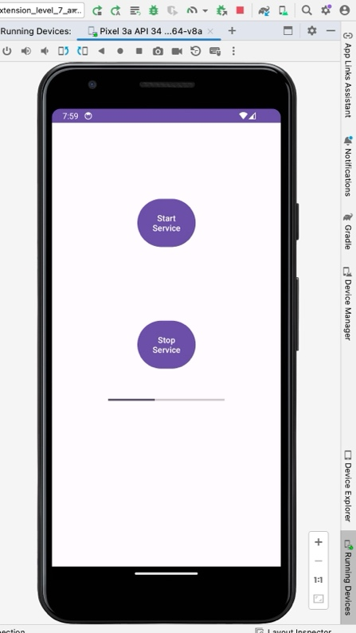
SS1 (Main activity). SS2 (progress bar half way)

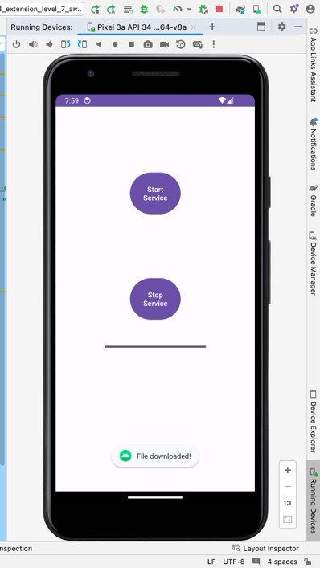

SS3 (file downloaded)

